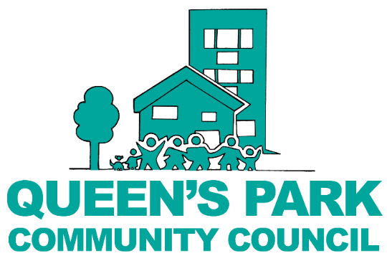

Pop-up Grants Programme

Who can apply?
The Queen’s Park Pop-up Grants Programme is intended for individuals living in Queen’s Park Ward, Westminster.

How much can you apply for?
You can apply for any amount up to £200. Please note that the Council cannot fund staff/workers costs for applications to the Pop-up Fund Programme.

Types of events/ projects funded
Pop-up Grants Programme funds projects, events or activities that align with the Council’s Grant themes. Initiatives can be open to the entire community or be targeted at specific groups, e.g. children or older people, so long as they are inclusive to all within that group.

When to apply
Applications are accepted on a rolling basis throughout the year. Ideally you should submit your application at least 6-8 weeks in advance of the proposed project / event date.

How to apply
Completed applications must be submitted to: grants@queensparkcommunitycouncil.gov.uk along with any supporting documents.
You can also submit a paper copy to the QPCC office: Beethoven Centre, Third Avenue W10 4JL.

Application Process
Applications to the Pop-up Grants Programme will be reviewed by Council officers who will make a decision, which is then report it to the Council in the next grants cycle.

Monitoring
Following the event or project, applicants are required to provide a brief written report on the event, including photos and receipts to prove how the funding was spent. We also ask that QPCC Officers and Councillors are invited to attend the event, if appropriate.

Support
Please refer to QPCC’s Grant Guidelines (LINK), the Grants page on our website or email: grants@queensparkcommunitycouncil.gov.uk for further support.

- About you
Name:
Address:
Telephone:
Email:
Describe your connection with the Queen’s Park community, Westminster:
- About your event/project/ activity
Name of event/project:
Brief description of your event/project:

Proposed dates:
Proposed times:
Who will attend / benefit from the project?
Please describe which residents have expressed support for the event:
How will the event be promoted?
- Project, event or activity finances
What is the total cost of your project?
How much money are you requesting from QPCC?
If the total cost is more than the grant, please explain how the remainder will be funded.
Please provide a detailed budget breakdown, including:
- Details of income and expenditure, including chargeable activities and staff costs
- Any in-kind donations
Description | Quantity | Cost
Total Requested from QPCC
Total Event/ Project Cost

- Declaration
Please read, type ‘Yes’ to agree to the following statements:
I have read the Council’s Grant Guidelines
The above information is accurate and has been completed to the best of my knowledge
My planned event, activity or project will be not-for-profit and is intended primarily to benefit the residents of Queen’s Park, Westminster.
I have read and agree to the terms and conditions of funding as outlined in the QPCC Community Grants Programme: Guidelines, terms and conditions approved by Queen’s Park Community Council.
I understand that all funds if not spent on the purpose for which they are granted must be returned to the Community Council.
I consent for my name and / or organisation to be used in QPCC publications that list QPCC grant funding awards.
- Consent for further communication
An important part of the council’s role is to keep people informed about our activities and projects, and how we spend public money. In order to share information with you, we need your consent. Please confirm your consent to our use of your contact information for this purpose, typing ‘Yes’ in the boxes below.
I give consent to be added to the QPCC mailing list to receive e-newsletters and updates to keep informed of news and events from QPCC and other local organisations, as well as what’s going on in Queen’s Park.
I would like to receive communications by email.
I would like to receive communications by mobile phone including text messages and WhatsApp.
You can find out more about how we use your data from our “Privacy Notice” which is available from our website www.queensparkcommunitycouncil.gov.uk or from the Community Council office. You can withdraw or change your consent at any time by contacting the council office. We look forward to hearing about your idea!
Sign: ……………………………………

Name: ……………………………………

Date: ……………………………………
Thank you!

